Miniature brains made from patient skin cells reveal insights into autism
PUBLIC RELEASE: 16-JUL-2015
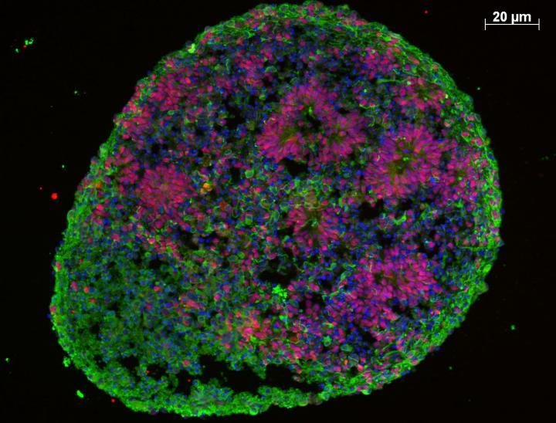
THIS IS A HUMAN BRAIN ORGANOID SHOWING COMPLEX INTERNAL ORGANIZATION, WITH IMMATURE PROLIFERATING CELLS (RED) AND A SURROUNDING LAYER OF MATURING NEURONS (GREEN).
Understanding diseases like autism and schizophrenia that affect development of the brain has been challenging due to both the complexity of the diseases and the difficulty of studying developmental processes in human tissues. In a study published July 16 in Cell, researchers have made steps toward overcoming these challenges by converting skin cells from autism patients into stem cells and growing them into tiny brains in a dish, revealing unexpected mechanisms of the disease.
Most autism research has taken the approach of combing through patient genomes for mutations that may underlie the disorder and then using animal or cell-based models to study the genes and their possible roles in brain development. Although this has yielded a handful of rare disease genes, the limitations of these models and the complexity of the disorder have frustrated researchers and left over 80% of autism cases with no clear genetic cause. The new study now turns the traditional approach on its head.
"Instead of starting from genetics, we've started with the biology of the disorder itself to try to get a window into the genome," says senior author Flora Vaccarino the Harris Professor of Child Psychiatry and Professor or Neurobiology at the Yale School of Medicine.
The clinical characteristics of autism are complex and wide-ranging, making the prospect of finding common underlying factors slim. To stack the deck in their favor, the researchers focused on the approximately one-fifth of autism patients that share a distinctive feature correlated with disease severity--an enlarged brain. After isolating skin cells from these individuals, as well as their unaffected fathers to provide a point of comparison, the researchers converted the cells into induced pluripotent stem cells that were then grown into miniature brains.
These so-called "brain organoids" are just a few millimeters in diameter but mimic the basics of early human brain development, roughly corresponding to the first few months of gestation. When the researchers analyzed the patient organoids, they uncovered altered expression networks for genes controlling neuronal development. Patient organoids showed an unexpected overproduction of inhibitory neurons that quiet down neural activity, while those that excite the partners they're wired to were unaffected, leading to an imbalance in neuron type. Remarkably, by suppressing the expression of a single gene whose expression was abnormally increased in patient organoids, the authors were able to correct this bias, suggesting that it may be possible to intervene clinically to restore neuronal balance.
With current technology, human brain organoids only recapitulate early stages of development; however, efforts to extend their growth to later stages are under way by a number of groups and will allow even further insights into disease mechanisms. The authors are now using their data to home in on the difficult-to-find mutations or epigenetic changes responsible for the gene expression alterations and neuronal imbalance observed in the study.
According to Vaccarino: "This study speaks to the importance of using human cells and using them in an assay that could bring a better understanding of the pathophysiology of autism and with that, possibly better treatments." The success of the approach also suggests that similar methods might be used to gain important insights into other human developmental diseases that have until now been difficult to crack open.
###
This work was primarily supported by the National Institutes of Health, the Harris Professorship fund, The National Institute of Mental Health, the State of Connecticut, and the Foster-Davis Foundation Inc. through the Brain and Behavior Research Foundation.
Cell, Mariani and Coppola et al.: "FOXG1-Dependent Dysregulation of GABA/Glutamate Neuron Differentiation in Autism Spectrum Disorders" http://dx.doi.org/10.1016/j.cell.2015.06.034
Cell, the flagship journal of Cell Press, is a bimonthly journal that publishes findings of unusual significance in any area of experimental biology, including but not limited to cell biology, molecular biology, neuroscience, immunology, virology and microbiology, cancer, human genetics, systems biology, signaling, and disease mechanisms and therapeutics. For more information, please visit http://www.cell.com/cell. To receive media alerts for Cell or other Cell Press journals, contact press@cell.com.
Disclaimer: AAAS and EurekAlert! are not responsible for the accuracy of news releases posted to EurekAlert! by contributing institutions or for the use of any information through the EurekAlert system.

